RFI # 1
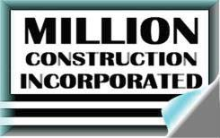

REQUEST FOR INFORMATION

Project: Building 1652 Pax River, MD

To: CJW DESBUILD JOINT VENTURE From: Million Construction, Inc.

Att.: Project Manager Contact: Jose Soto

Ph.: Phone: 703-978-2174
Fax: Fax: 703-978-2175

QUESTION AND CONCERNS
Date of Request | __3___-__31___-___15__ |  | Response Needed |  |  | _____-_____-_____
RFI Description: Working Drawing 65%

Project Super has 65% drawing. Also we have 65% drawing same date, but the drawings are not
The same.

What do we do?

As Field Inspection |  | Spec. Paragraph: |  | Drawing Reference:
Cost Impact: TBD |  |  | Schedule Impact: TBD
Subcontractors affected: Million Construction, Inc.
Subcontractor Coordinated:.
Submitted by: Jose Soto
RESPONSE
Response by: |  |  |  |  | Date:

8917 Burke Lake Rd, Springfield, VA 22151 • Ph: 703-978-2174 • Fax: 703-978-2175| 1

