 |  | PURCHASE ORDER

Million Construction, Inc.  8917 Burke Lake Rd, Springfield, VA 22151  703-978-2174 / 703-978-2175  www.millionconstruction.com |  | Date: July 30, 2026  p.o. MC-2014-06-01  Delivery date: August 17, 2016 morning
SUBCONTRACTOR  OR  VENDOR | Stainless Supply  307 N. Secrest Ave.  Monroe, NC. 28110  Scott Hauggins  877-484-0088  Scott@stainlesssupply.com | Project | Montgomery College  Physical Education Building  Germantown, Campus  20200 Observation Drive  Germantown, MD. 20876

qty
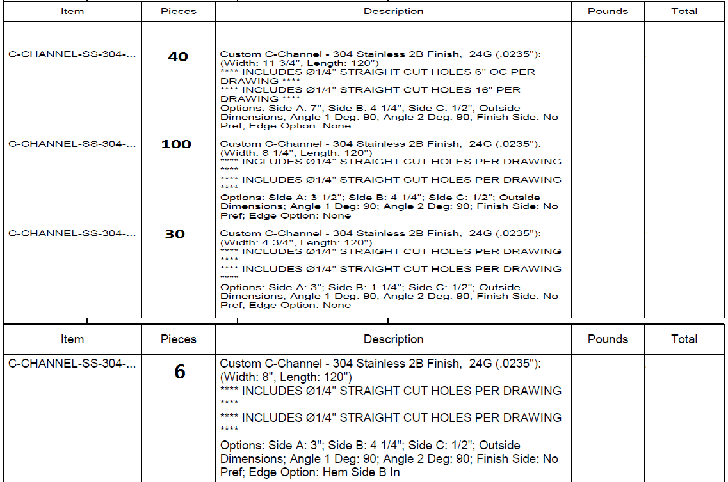

- Enter this order in accordance with the prices, terms and specifications listed above.
- Send all correspondence to:
Million Construction, Inc.
8917 Burke Lake Rd
Springfield, VA 22151
Att: Jose Soto

- Please sign and return one copy for our records.
 | Authorized by Jose Soto | Date 08/11/16
 | Accepted by………………………. | Date ………

